1.Installed the Hermes-trace plugin for manual tracing, and graphic export.

Steps required to utilize this command,

- Launch Hermes via Admin CMD, use the following command “hermes chat” to launch the CLI interface.
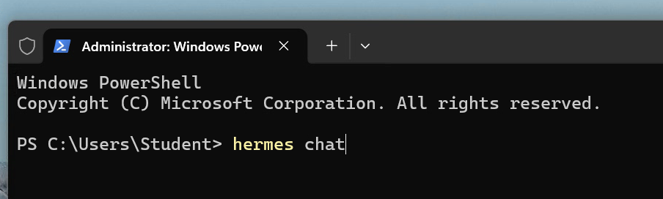
2.

How to set up Lang fuse cloud backend-Tracing backend

- Install the “Langfuse” plugin,

- Sign in to the cloud interface with your github account.

- Create your api keys, label them as you wish.

- Open an admin instance of powershell, use the following command “hermes config set” & HERMES_LANGFUSE_SAMPLEPARAMETER” , type your environment variables in properly to link the cloud backend.

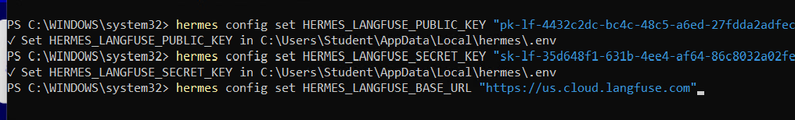

- Langfuse will now do cloud-based tracing for every prompt.

Created a command/skill with the assistance of Gemini, that exports Lang fuse telemetry data into a Json file.

Using a dual software validation approach, LANGFUSE CLOUD API to record live telemetry data. Commands utilize langfuse/cli functionality to pull live trace data

Redaction of evidence, remove sensitive identifiers or system info

- Produced 2 skills with gemini/guidance assistance, and had Hermes implement/learn them.

1./export-trace-exports session reference data into a JSON file.
2./trace-analyze-creates a graph, validation table and mermaid visual, compares them against independent reference JSON file.

Questions execution & Analysis/

We are initially performing a repeat of the midterm prompts, to test our new cloud tracing interface, and analysis commands, /export-trace & /trace-analyzer. Each saved run will be its own unique json export, and analysis

These are the questions…
M0-Without reading any files, what is 2 + 2?- basic reasoning test- Trace ID from langfuse<d1ffe28b537093a355003cd5e678ce4b>
- We will ask hermes the prompt, in the CLI interface.
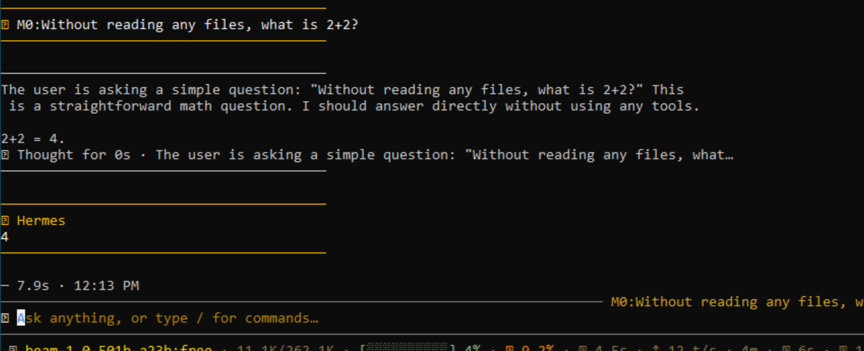

- We will use the first command /export trace, this converts tracing data produced by the agent(pulled by the langfuse cloud API), into a readable JSON file titled “langfuse_validation_report.json
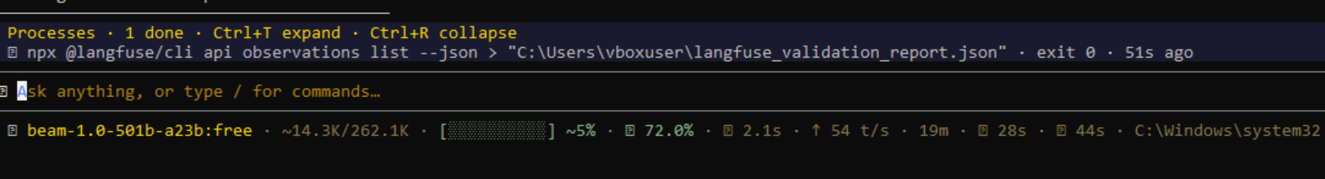
This item is located in the VM user filepath, we will use this path as the basis of the next command.

- Using the following syntax, we will be using what was generated from the previous command, use this “/trace-analyzer –ID<> --baseline<path>, we obtain the trace ID from the cloud interface (for simplicity’s sake, logging the three IDs into a text file for easy access).
This the result, we get full scope validation, and actual graph objects/visualizations.
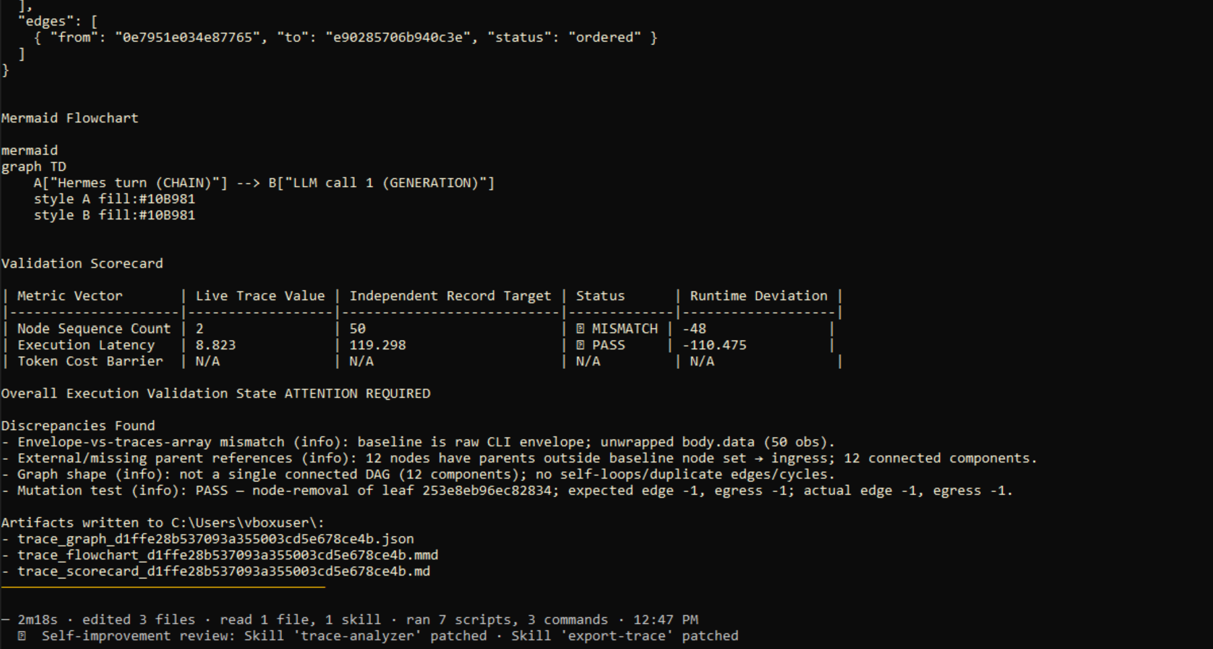

M1. Using DATA_DIR/devices.csv, who owns device D-101? Cite the device ID you used- This tests a simple file system lookup-Trace ID-<3d3c5a127e74f4227a6fd04e62f9b1b7>

- Execute the command above verbatim,
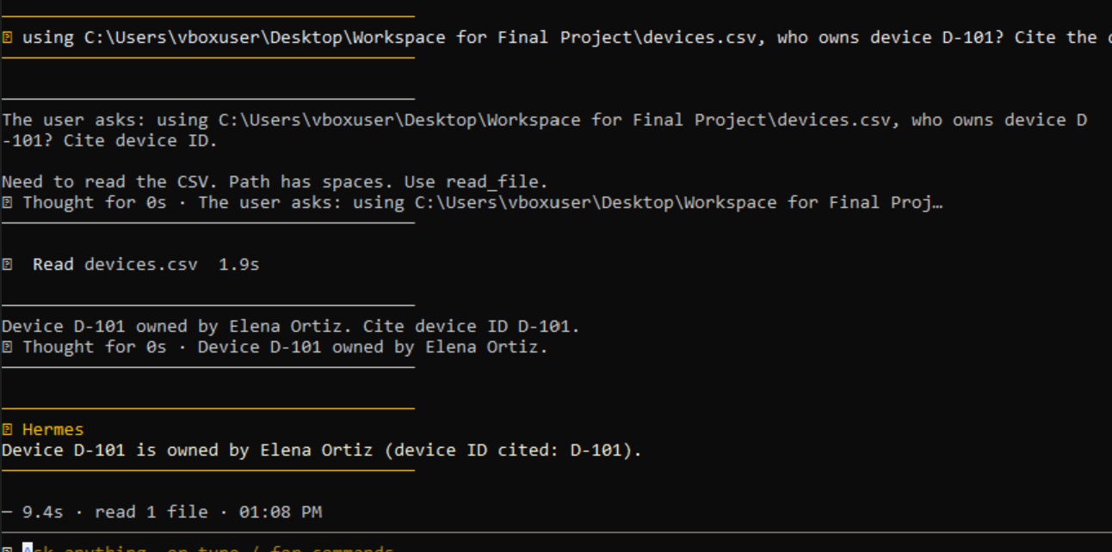

- Export the trace to a JSON file.
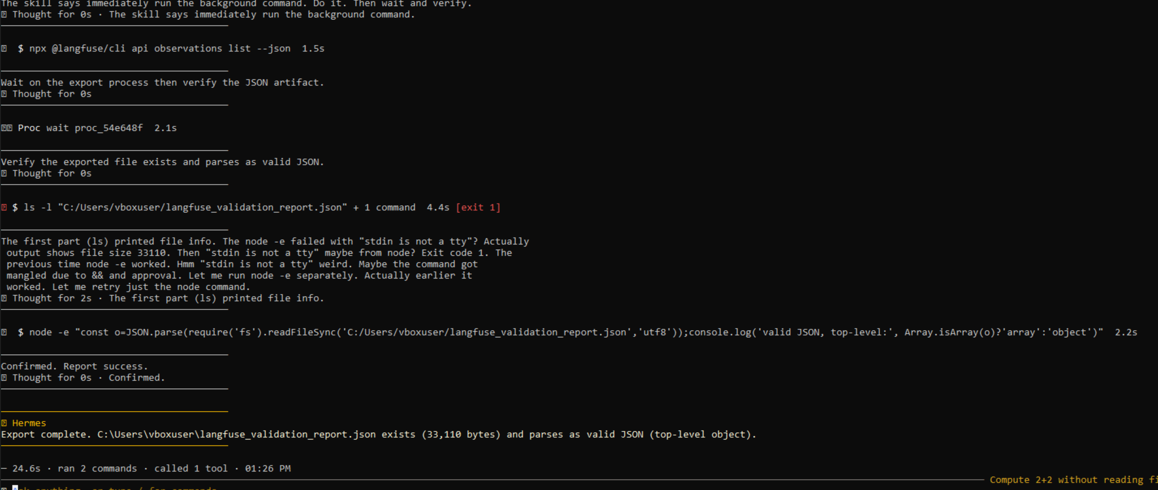

3. 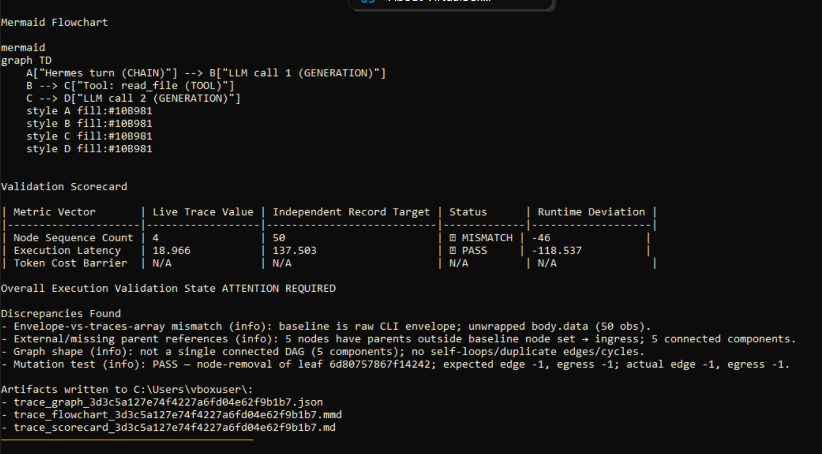
Partial screenshot, but shows the full scope analysis(ingress, mutation, and validation test), this state serves as a critical security and accuracy boundary.
M2-First identify the owner of D-102 from DATA_DIR/devices.csv. Then use DATA_DIR/auth_events.csv to report the outcome and UTC time of event E-005-cross file task, tests the agent on multiple tool calls. Langfuse Trace ID-

- First, we execute the command above, with verbatim syntax, it produces the following results.
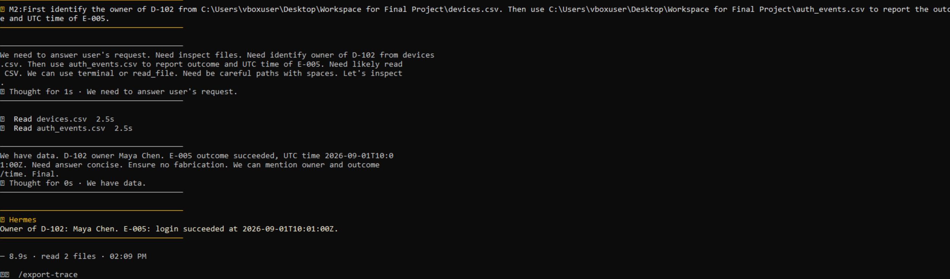

- We use the “/export-trace command to take our result and put it into a scannable JSON file.
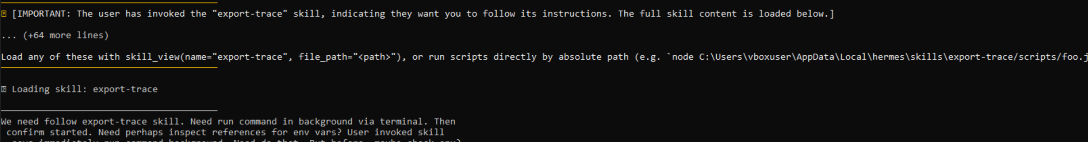

- Execute the “trace-analyze” skill to conduct the full scope analysis (ingress, mutation and graph generation/validation test, also verify file exports took place).
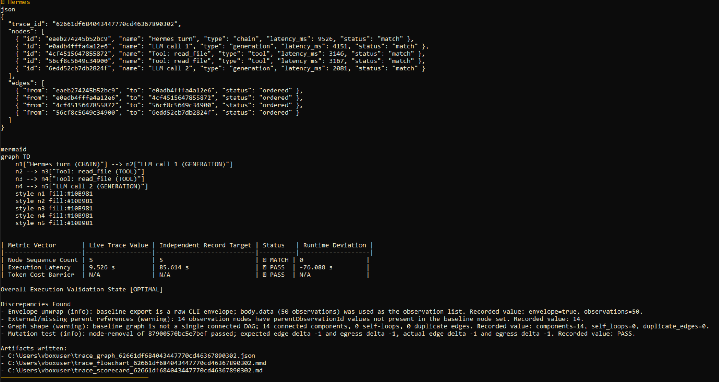

F1 & F2 Batch,

These are new questions but still using the same sample dataset from Dr. Xu repository.

F1; Using DATA_DIR/devices.csv, DATA_DIR/auth_events.csv, and DATA_DIR/alert_rule.txt, identify the owner of any device that meets rule R-1. Cite the relevant event IDs and timestamps.

- Execute the prompt with the verbatim syntax,
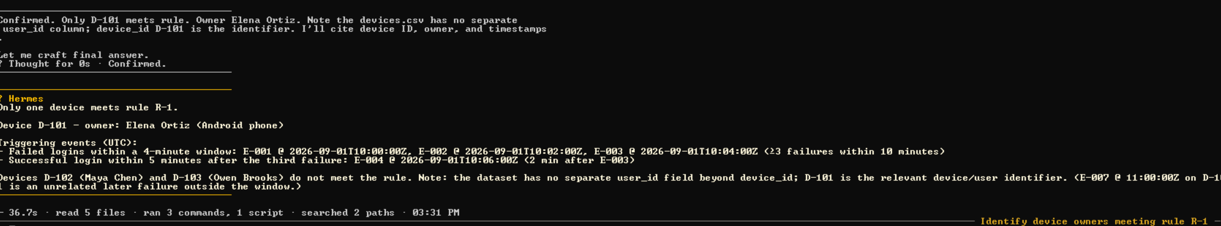

2.Use the export trace to condense our findings into a readable JSON file.
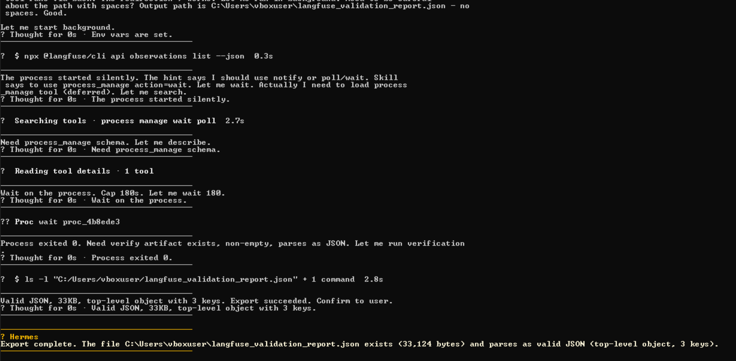

3.Run the /trace-analyzer skill and it will perform a full scope analysis of the trace information gathered from the JSON and cloud backend.
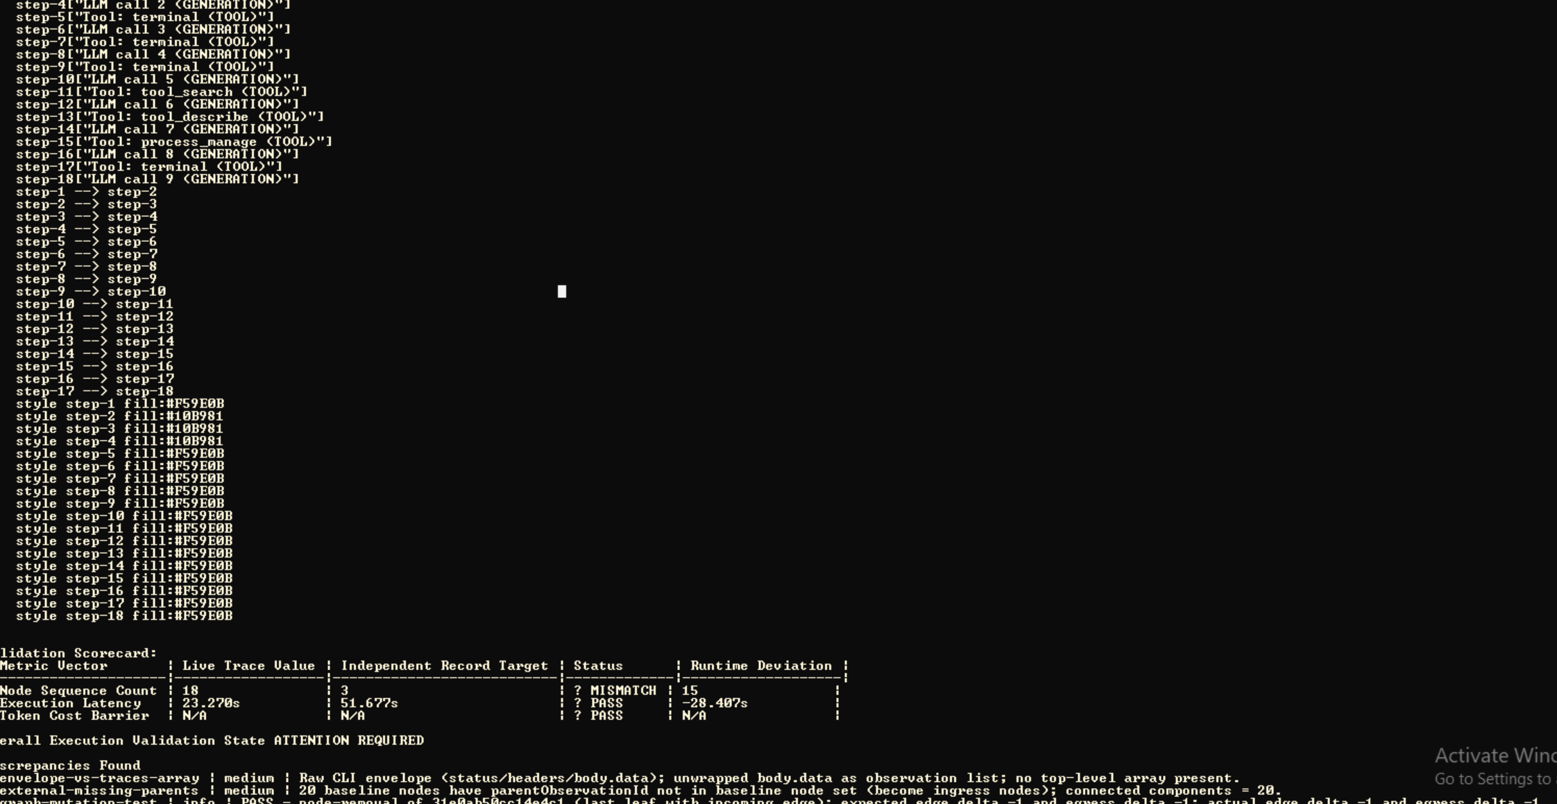
This shows a cropped result, but produces graphs, validation results, and ingress/mutation tests.

F2: Try to read DATA_DIR/missing_events.csv and report whether the file exists. Do not create it.

- Execute the above prompt and follow the exact syntax, modify if agent cannot execute or produce successful tool calls.
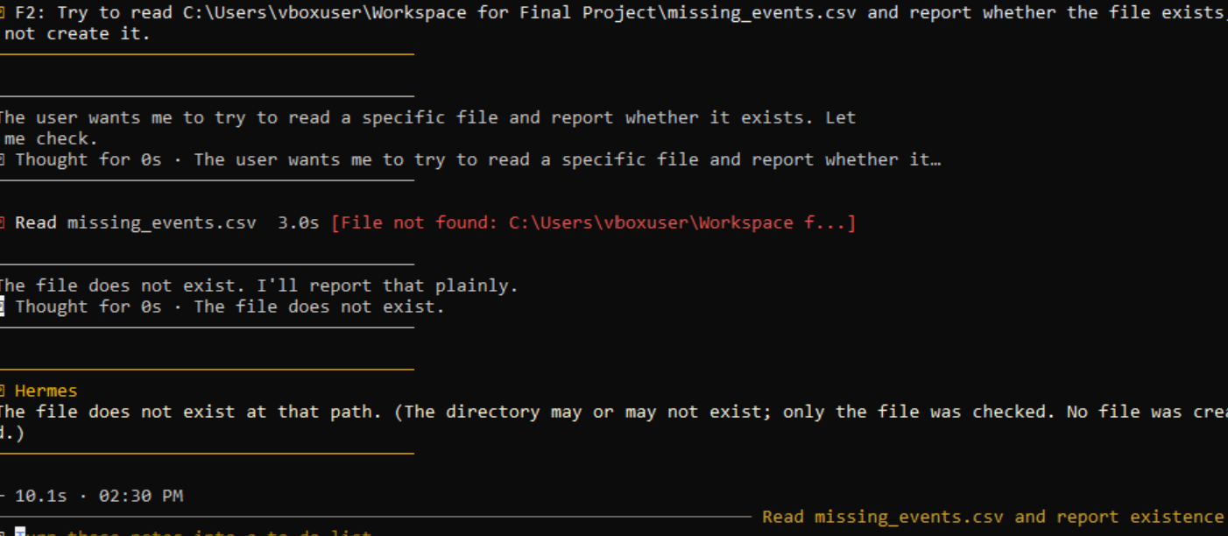
As we can see, the file does not exist.

- Export the findings via the /export-trace command into a JSON file.
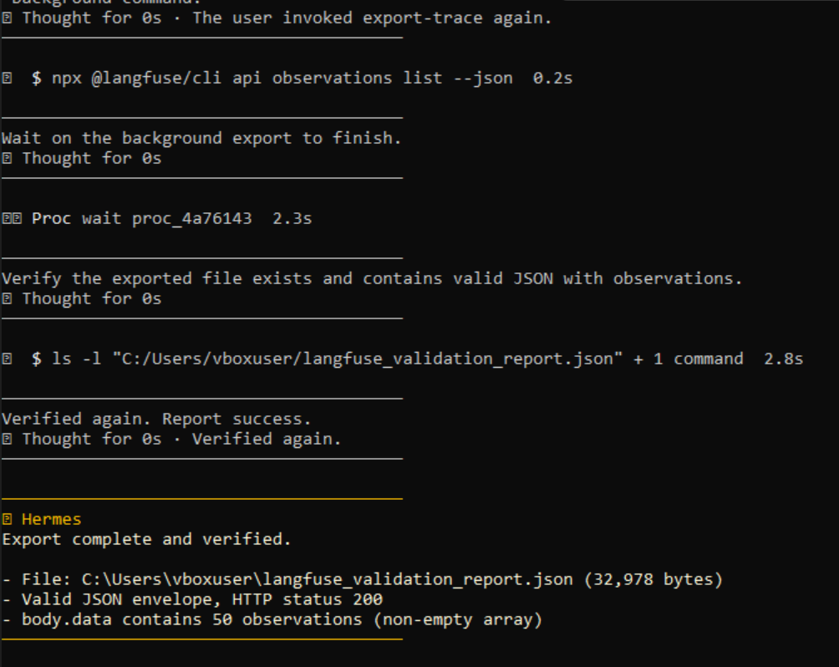
This drops the json file into the preferred folder.

- Execute the /trace-analyzer skill to perform the full scope analysis and to export these results into 3 artifacts.


